Part A:

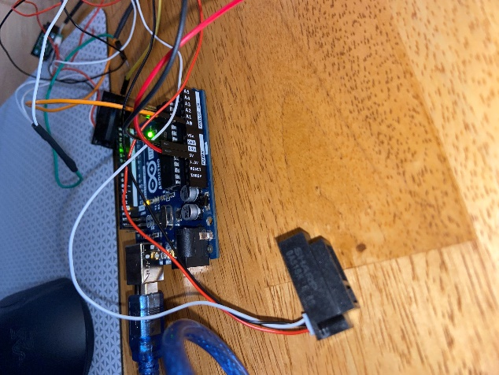

Part B:

Part C:

